Kontakt: | Putzmeister Concrete Pumps GmbH  Marketing Manager  Sany Allee 1  D-50181 Bedburg  Tel.: +49 2272 90 531 116  E-Mail: timm.hein@putzmeister.com | Presse-Information Nr.:  Datum:  Autor: | 2025-02.01  Februar 2025  Timm Hein

SANY AT BAUMA 2025 – YOUR PARTNER TO CREATE THE BEST

Machines that impress – Innovation, performance, and sustainability on 3,000 square metres

Bedburg/Munich, February 2025 – From April 7 to 13, 2025, Munich will become the global hub for the construction and construction machinery industry. SANY will present itself at bauma 2025 with an impressive 3,000 square metre exhibition stand (FN619, Outdoor Area North) and more than 35 machines, including several new product launches. From powerful excavators, wheel loaders, and telehandlers to forklifts, cranes, concrete pumps, and the latest road construction machines, SANY is showcasing its full range of equipment.

A trade fair setting new standards
Under the theme “SANY – THE WORLD OF EFFICIENCY – Your partner to create the best,” SANY will demonstrate how innovative technology, efficiency, and sustainability are shaping the future of the construction industry. SANY is not only focused on innovation but also on building strong strategic partnerships—an essential advantage for customers and dealers across Europe and worldwide.

Experience Innovation and Strong Partnerships
Over the past years, SANY has established itself as a major construction machinery manufacturer in Europe. With a strong dealer network, innovative machines, and an attractive price-performance ratio, SANY has become a key player in various sectors.

SANY's strengthened presence across Europe is a testament to these partnerships. New sales and service regions have been established to be closer to customers, better understand their needs, and pave the way for a shared future.
SANY invites all visitors to experience the full range of machines up close at booth FN-619 (Outdoor Area North).

Compared to 2022, SANY has doubled the size of its bauma exhibition stand, a clear sign of continuous growth and the increasing importance of the European market. SANY remains committed to presenting machines and solutions that are precisely tailored to regional customer needs. This is made possible with modern, high-performance, and competitively priced machines that empower customers worldwide to implement their projects efficiently and economically.
Industry professionals will have the opportunity to interact directly with on-site experts, receive personalised consultations, and experience the latest innovations live. bauma provides the ideal platform to explore cutting-edge technologies and establish valuable connections within the industry.

Efficiency for Landscaping – SANY Mini Excavators at bauma 2025
For visitors from the landscaping industry, bauma 2025 holds numerous highlights at the SANY stand. Landscape gardeners, municipalities, and construction companies specialising in outdoor facilities face unique challenges: limited space, sensitive ground conditions, and diverse applications require compact, precise, and cost-effective machines. SANY offers the perfect solution with its advanced mini excavators for planting, earthworks, paving, and green space maintenance.

Visitors can look forward to a true premiere: the SY10U, SANY’s first micro-excavator, features an ultra-compact design and a hydraulically adjustable undercarriage (745–1100 mm), allowing it to fit through standard doorways—ideal for confined garden spaces, paving work, or urban greening projects.

The SY35E showcases a sustainable solution for emission-free operations. This fully electric mini excavator provides up to six hours of runtime, 30% lower energy consumption, and fast charging capabilities—perfect for emission and noise sensitive projects.

The SY60U, a compact 6-tonne excavator, offers high performance and precise control, making it ideal for earthmoving, tree clearing, or pathway construction. With a 42.4 kW Yanmar engine and support for 20 attachments, it provides maximum versatility.

Highlights in the Large Machine Segment (Excavators and Wheel Loaders from 8 Tonnes)
For deep excavation, pipeline construction, and demolition companies, SANY presents the right machines for every construction site. The SY155U 2PB (with two-piece boom) combines exceptional manoeuvrability with powerful performance. Featuring a swing boom and dual auxiliary hydraulic circuits, it is perfect for high-performance attachments like log harvesters or mulchers. A redesigned 7-inch touchscreen ensures intuitive operation, while an elevated dozer blade improves grading efficiency, making it a machine that combines productivity and comfort.
Also featuring a swing boom, the SANY SY215C NLC 2PB is a tracked excavator with an operating weight of approximately 22 tonnes.

The SY215E is a groundbreaking alternative in the 23-tonne class. This fully electric crawler excavator, equipped with a 150 kW electric motor and a 422-kWh lithium iron phosphate battery, provides a zero-emission, low-noise solution for sustainability-focused customers.

The SY305LC LR is a 32-tonne class machine and a special variant of the proven SY305C. It features a long-reach attachment with an 11.8-metre boom and an 8-metre stick, effectively doubling the reach compared to the standard model.

With the SW956E, SANY is introducing a fully electric 20-tonne wheel loader, offering both high performance and sustainability. This model complements the portfolio, where the combustion-engine SW405 has already established itself as a success.

Material Handling Highlights
With rising demands for higher efficiency, lower emissions, and maximum productivity, SANY provides the right solutions: powerful material handlers, fully electric wheel loaders, and versatile telehandlers designed for ports, recycling plants, and heavy-duty logistics.

Making its official debut, the 40-tonne material handler SMHW40G5 sets new benchmarks in efficiency, performance, and sustainability. Designed for scrap processing and heavy-duty material handling, it combines power, precision, and environmental friendliness.
SANY is also launching the STH742, a compact yet powerful telehandler with a 7 metre lift height and a 4,200 kg payload, offering a versatile solution for construction, industry, and logistics.

The brand-new STH625e represents SANY’s electric revolution in telehandlers. With a 2.5-tonne lift capacity, it delivers maximum performance with minimal dimensions. A large battery ensures an 8-hour workday, just like the diesel variant.

Road Construction Highlights
Modern road construction machines play a crucial role in building durable and safe infrastructure. The new STR50E electric roller is the first fully electric 5-tonne roller, expected to be available from late 2025.

With the STR27C, SANY introduces the next generation of tandem rollers. As the successor to the STR30, it will be available from June 2025 and features innovative high-frequency vibration technology for faster, more efficient, and comfortable compaction.

Highlights in High-Rise Construction
At bauma 2025, SANY will showcase its crane portfolio, highlighting its growing market presence in Europe. SANY will present mobile and crawler cranes specifically tailored to the demands of the European market. Strict building regulations, increasing sustainability requirements, and complex approval procedures make crane operations particularly challenging in Germany, Austria, and Switzerland. SANY addresses these challenges with innovative, durable, and cost-efficient crane solutions, including all-terrain cranes (SAC1200E), crawler cranes (SCC2000A-EV), rough-terrain cranes (SRE450N), telescopic crawler cranes, lattice boom cranes, and truck-mounted cranes. A dedicated team has been established in Germany to understand regional requirements and develop products tailored to market needs.

Maximum Reach and Precision – SANY and Putzmeister Present Innovative Concrete Pumps
With its new SANY truck-mounted concrete pumps, SANY, in collaboration with Putzmeister, is setting new standards in reach, flexibility, and efficiency. From the compact SY32 Z5-160, ideal for confined construction sites, to the powerful
SY68 RZR6-180, which effortlessly handles large-scale concreting tasks with its 67.3-metre reach height.

The Exhibition Stand
With its new trade fair presence, SANY is taking a significant step forward. The booth is divided into two levels, with the upper floor offering hospitality, spacious meeting rooms and a premium VIP lounge for dealers and invited customers.

More than just an exhibition space, the SANY stand will be an interactive experience for industry experts and customers. Highlights include a “Driver Bar,” a demo area where excavators will showcase their versatility, and a dedicated merchandise shop. In addition, state-of-the-art digital solutions will take centre stage—including the SANY fleet management system, designed to enhance efficiency and transparency in construction machinery operations.

Enhanced presence in Europe
By establishing national subsidiaries for sales and service across Europe, SANY is better positioned to support customers comprehensively.

For the DACH region, the collaboration with SANY subsidiary Putzmeister is a highlight. Putzmeister, one of the world’s leading brands in concrete technology, plays a vital role in SANY’s European strategy, providing customers and dealers with a broader product portfolio, optimised sales structures, and enhanced service. This partnership ensures that construction companies receive the best solutions for efficient and cost-effective operations.
For more details, visit www.sanyeurope.com or visit us at bauma 2025, Stand FN-619!

--- All information and images of the product highlights can be found in the respective product press releases, which we have provided along with this press release. ---

Picture:

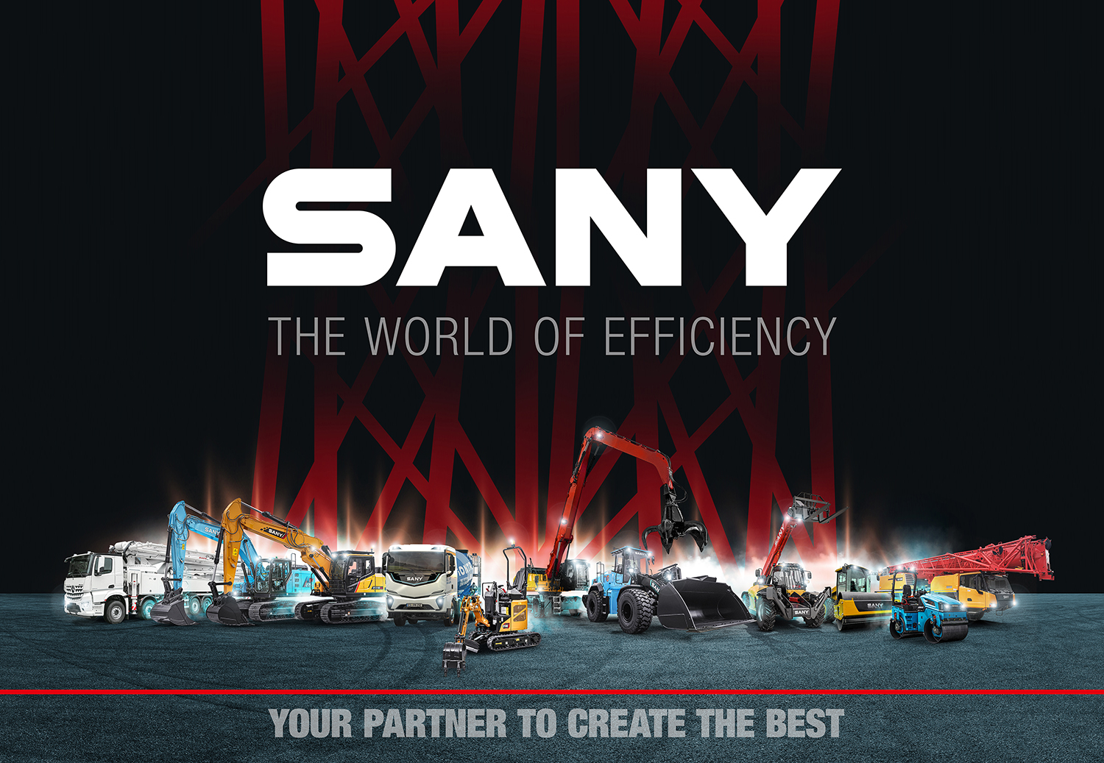

Pic. 1: SANY’s guiding theme for BAUMA 2025

About SANY

SANY Europe is a company of SANY Heavy Industry from Changsha. This is one of the three largest manufacturers of construction machinery in the world. Founded in 1989, the company offers a broad product portfolio with over 18 product families and more than 500 machine models. This is developed, realised and sold by almost 60,000 employees worldwide.
SANY's European site is in Bedburg, near Cologne, since 2011. The site employs staff in Sales, Service and in adapting products for the European market.
SANY Europe's portfolio focuses predominantly on excavators, port-machinery, cranes and road-machinery.

Integration Putzmeister
The globally renowned Putzmeister brand, headquartered in Aichtal near Stuttgart, is also part of SANY Heavy Industry.
Since 01.11.2024, Putzmeister has taken over the sales activities for SANY construction machinery products in the DACH region.
Putzmeister is thus following its global expansion strategy, having already taken over sales for SANY products in the Iberian region, Turkey and Australia have already been taken over for SANY products.

